**MEMBERSHIP PROFILE**

**PRIVACY NOTICE**

.

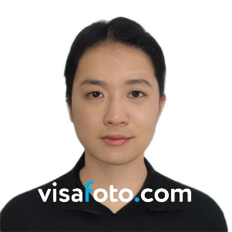

**Institute of Computer Engineers of the Philippines Student Edition**

**Name of Organization**

|  |  |  |  |  |  |  |  |  |
| --- | --- | --- | --- | --- | --- | --- | --- | --- |
| **PERSONAL INFORMATION** | | | | | | | | |
| *Last Name*  {{ last_name }} | *First Name*  {{ first_name }} | *MI*  {{ mid }} | | *Age*  {{age}} | | | *Sex*  {{ sex }} | *Civil Status*  {{ status }} |
| *Date of Birth*  {{ birth_date }} | *Place of Birth*  {{ birth_place }} | | | | | | | *Religion*  {{ religion }} |
| *Permanent Address*  {{ permanent_address }} | | | *City Address (If boarding)*  {{ city_address }} | | | | | |
| *Course & Major*  Bachelor of Science in Computer Engineering | | | | | | | | *Year Level*  {{ year_level }} |
| *Talent/Skills*   1. {{ talent1 }} 2. {{ talent2 }} 3. {{ talent3 }} 4. {{ talent4 }} | | | | | *Position in the Organization*  {{ organization_position }} | | | |
| *Date Entered in the Organization*  {{ date_entered }} | | | |
| *Membership to*  *other*  *Organizations* | {{ membership1 }}  {{ membership2 }}  {{ membership3 }} | | | | *Position*  {{ position1 }}  {{ position2 }}  {{ position3 }} | | | |
| **PARENTS’ INFORMATION** | | | | | | | | |
| *Father’s*  *Surname*  *First Name*  *Middle Name* | {{ father_surname }} | *Mother’s*  *Surname*  *First Name*  *Maiden Name* | | | {{ mother_surname }} | | | |
| {{ father_first }} | {{ mother_first }} | | | |
| {{ father_mid }} | {{ mother_mid }} | | | |
| *Date Signed*  _____**{{ printedName }}**  *Signature over printed name of Member* | | | | | | *Contact Number*  {{ contact }} | | |
| *Email Address*  {{ email }} | | |
| Attested by:  **{{ president_name }}** *Signature over printed name of President/Head*  **{{ assist_adviser_name }}** *Signature over printed name of Assistant Adviser*    **{{ adviser_name }}** *Signature over printed name of Adviser* | | | | | | | | |